UNIT 4: MUSIC AND ARTS
Period 30: Lesson 4: COMMUNICATION
- Learning outcome: By the end of the lesson, the students will be able to:
* Knowledge
- Know some extra words related to the topic " music and arts".
- Have an opportunity to take part in a quiz to revise their general knowledge about music and arts in Vietnam and in the world.
- Give and share opinions about the importance of music and arts in both education and life.
* Skills: Develop Ss’ speaking skill.
* Attitudes
- Students have the love for music and arts.
II. Materials and references: Textbook, lesson plan, chalk, color chalk, board, handouts
III. Anticipated problems: Students may not know well about the past. Teacher should help
IV. Proposed solutions: The teacher should prepare the lesson carefully and give the students clear instructions
LESSON PROCEDURES
Competence | Learning activities | contents |  |  |  |  | Modes
WARM UP (6’)
Ask ss to discuss the advantages of music, dance, singing, painting and photograph
Self learning  language  communicative  Problem- solving | - Ask the Students to copy down.  - Checking Vocabulary:  (mime)  - Brainstorm with Ss to give the names of famous musicians, actors, actresses, painters, and music bands they know. This can be done in groups. Each group then has to show the list they have written. (The group that has the longest list wins the game).  - T choose 2 MCs to control the Quiz.  ACTIVITY 1  1. B 2. C 3. A 4. C 5. B 6. B  - T asks ss some information about Titanic and let them listen to the song “My heart will go on”  - T decides the winner. | I. VOCABULARY (7’)  - (to) originate : to com from a place for the first  - anthem : a particular song of a country , often sung on special cases  - curriculum: subjects studied in a school, college  - compulsory (adj): you must do it because of a rule or law:  - academic ; thuộc về hàn lâm ( translation)  - COMMUNICATION  - Game: (Quiz) (8’)  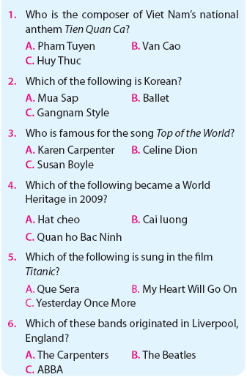
PRESENTATION (5’)
To give Students chance to know more about landmarks and introduce some more vocab
self learning | ACTIVITY 2:  -Give Ss plenty of time to work independently, read the text, and understand the main ideas.  - T checks the understanding of the students by asking some questions.  T divides the class into groups of six to discuss the questions. T goes round the class to give support if necessary.  Do you think music and arts should be compulsory subjects at schools in Viet Nam?  Why or why not? |  | - Speaking  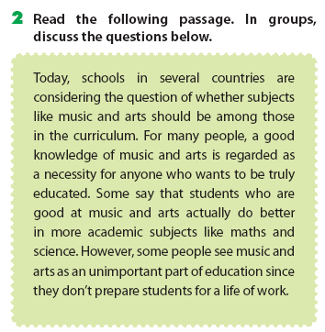 |  | Individual and  Pair work
PRACTICE (DISCUSSION) (12’)
Collaboration  creative  Collaboration | T gives Ss time to work in groups of four to six to make a list from the most useful to least useful subjects given. How can the top three subjects on the list help them in other areas of school and life?  After the discussion, each group presents their list, and gives a talk to the class. T then gives comments. |  | - Suggestions:  Music and arts should be compulsory subjects at schools in VN:  - Students who are good at music arts can do better in more academic subjects like math and science.  - A good knowledge of music and arts is a necessity for any one who wants to be educated  - Music speaks to emotions and helps Ss to relax their mind.  - Arts improve students’ observing skills, creativity and logical thought.  - ……..... |  | -
FURTHER PRACTICE (7)
Helping Students to sum up whole knowledge from speaking by discussing the importance of music and arts in the areas of school and life.
Collaboration | T asks Ss to work in pairs to discuss the importance of music and arts. |  |  |  |  | work in pairs
OUTCOME AND HOMEWORK (1’)
self learning | - Learn the words in Extra vocabulary by heart.  - Write a short paragraph about the importance of music and arts in the life  - Prepare Unit 4- Lesson 5: Skills 1  Reading and Speaking |  |  | Guideline |  |  |  | - Copy and listen T’s guideline

